Web Application: heicheleList

Framework: Web2py

Developer: Tim Heichele

Course CSC 438

Link to public website: timheichele.com

Test account user: [massimo.dipierro@depaul.com](mailto:massimo.dipierro@depaul.com)

pw: csc438

Purpose of the web application

heicheleList purpose is to allow people in need after a declared natural disaster. The website will provide a way for the people to search

for products they need but don’t have the means to afford the product. The products are donated from user that have the means to donate

a product or have the means to donate money for delivery of a product. So the vision of the webpage is when in need: Find your need.

Workflow of heicheleList

Home page

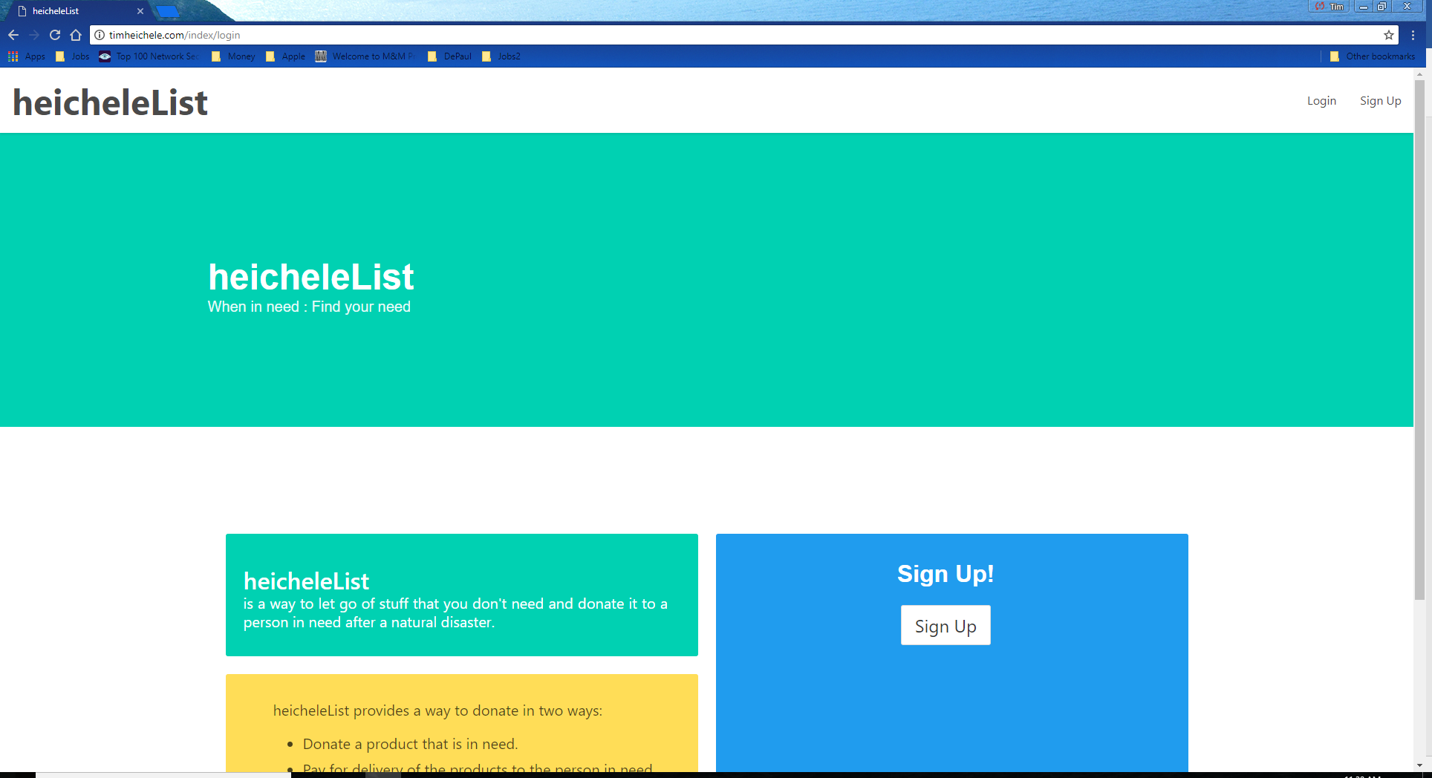

The home page allows you to sign up for heicheleList, and login, both sign up and login pages will take you the home navigation page of heicheleList.

Login and sign up page

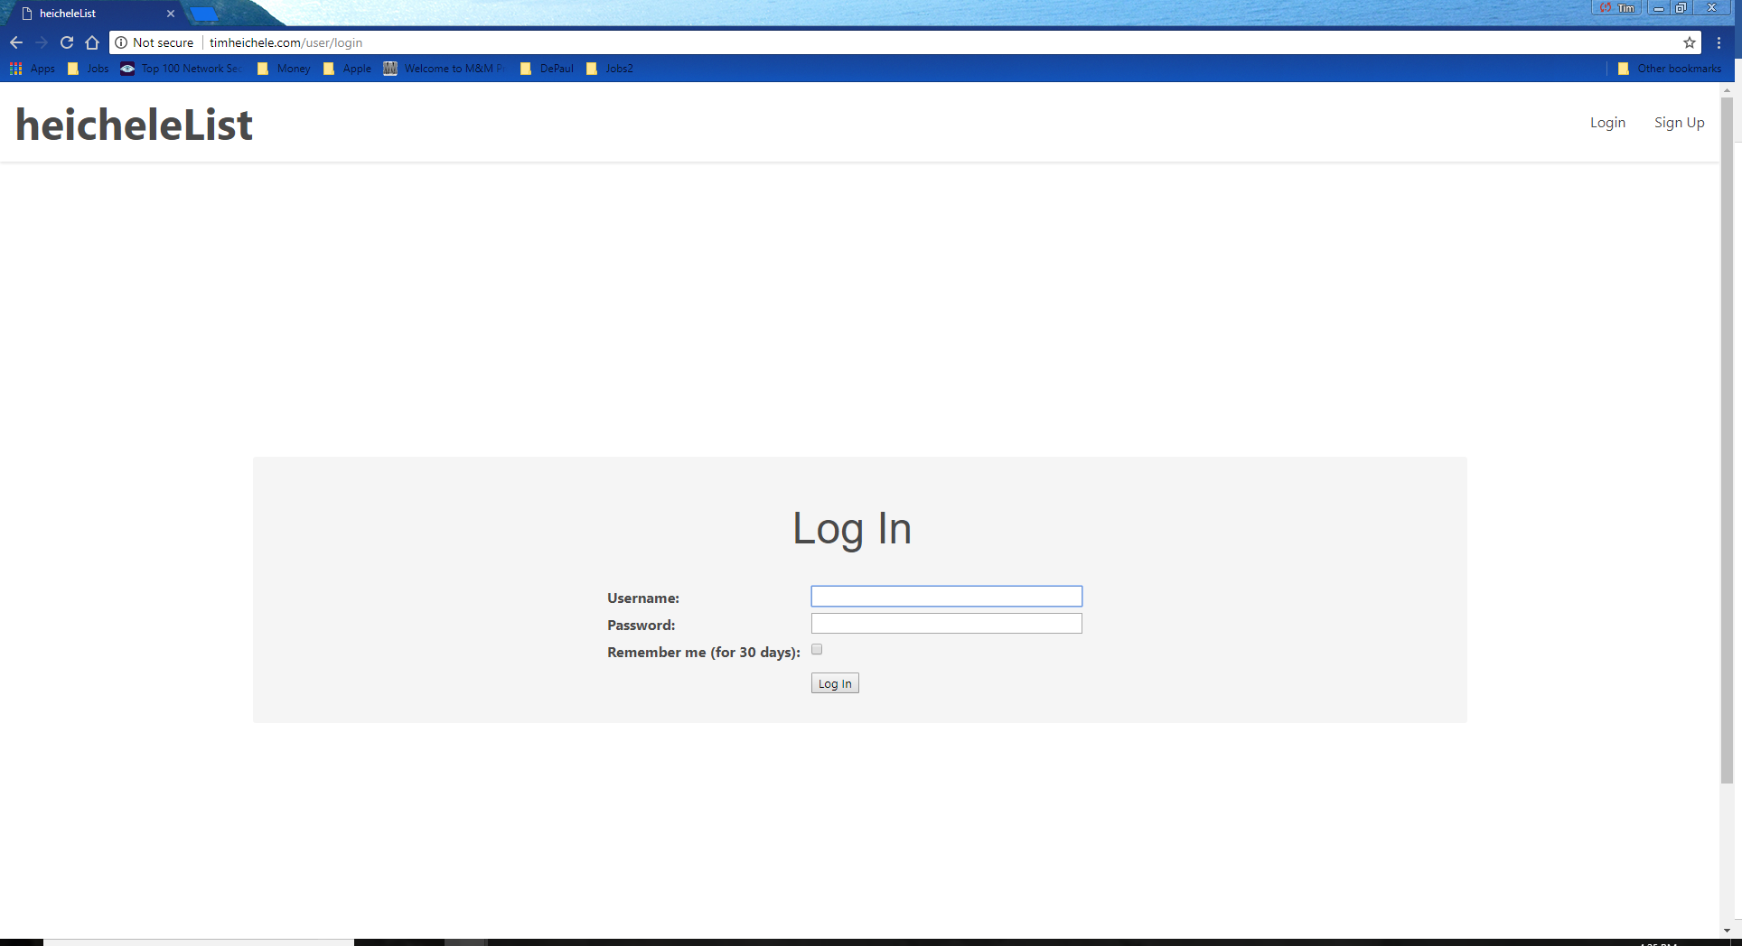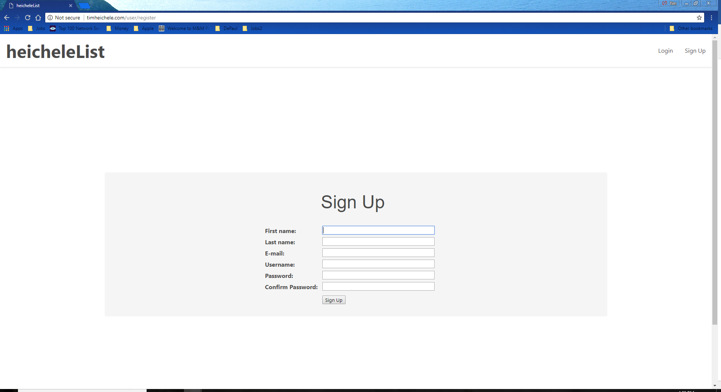

home navigation page

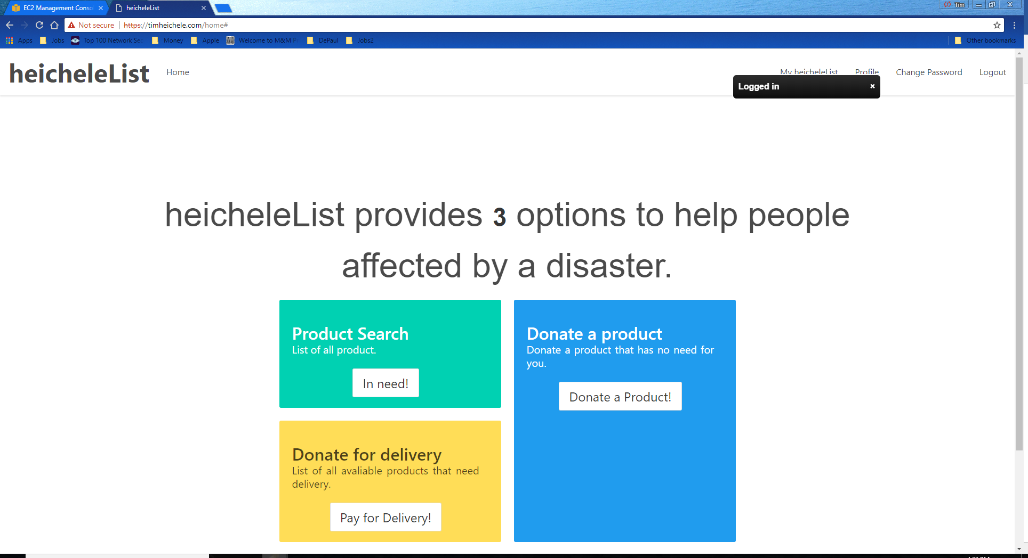

Provides three options for the main purpose of the web page. Donate a product, Product Search, and Donation for delivery.

And once the user is logged in the navbar provides functionality to always come back to the home navigation page, update profile, My HeicheleList,

change password, and logout.

**Purpose 1: Donate a product**

**Product Entry page**

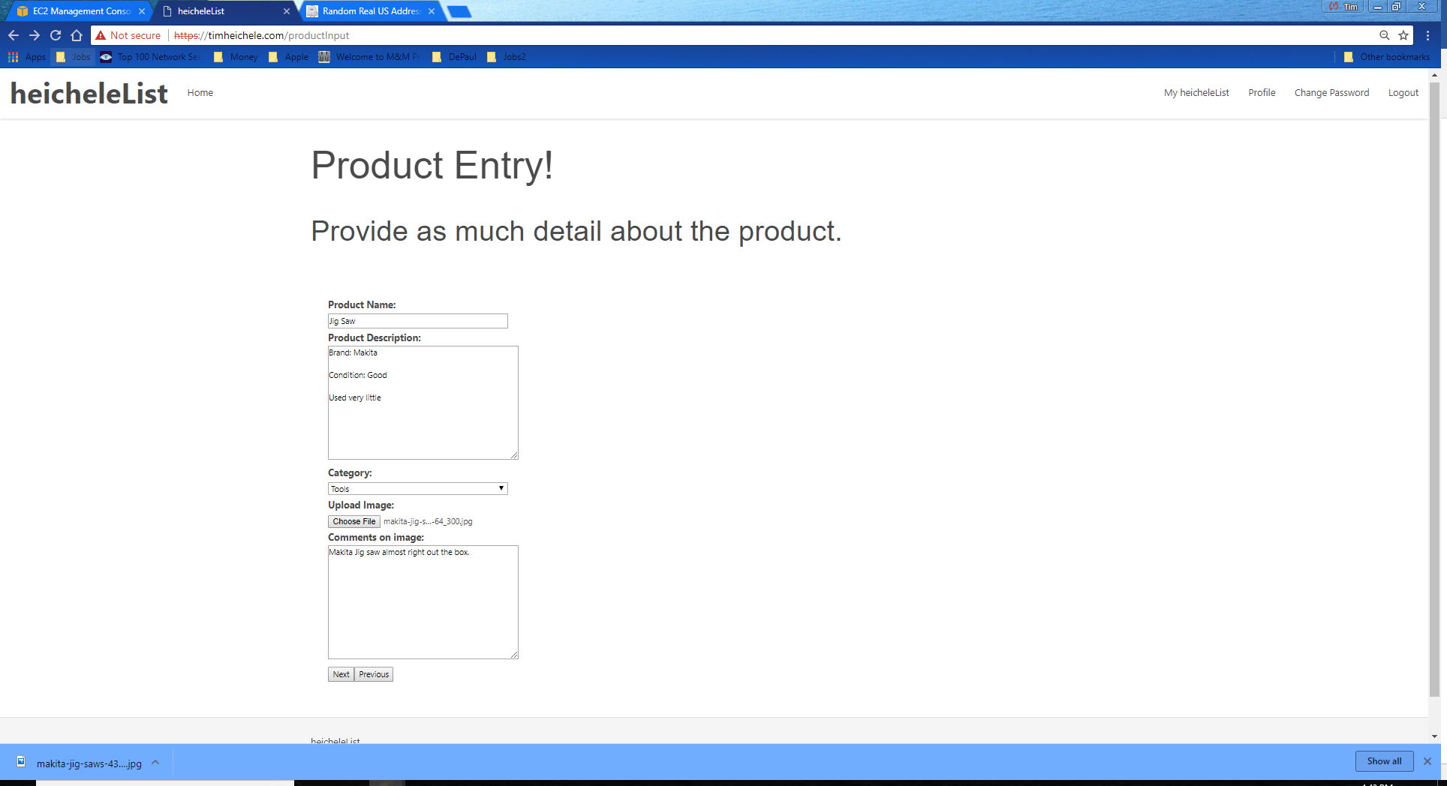

Allows the user to enter information about the product they are about to donate.

**Product home address page**

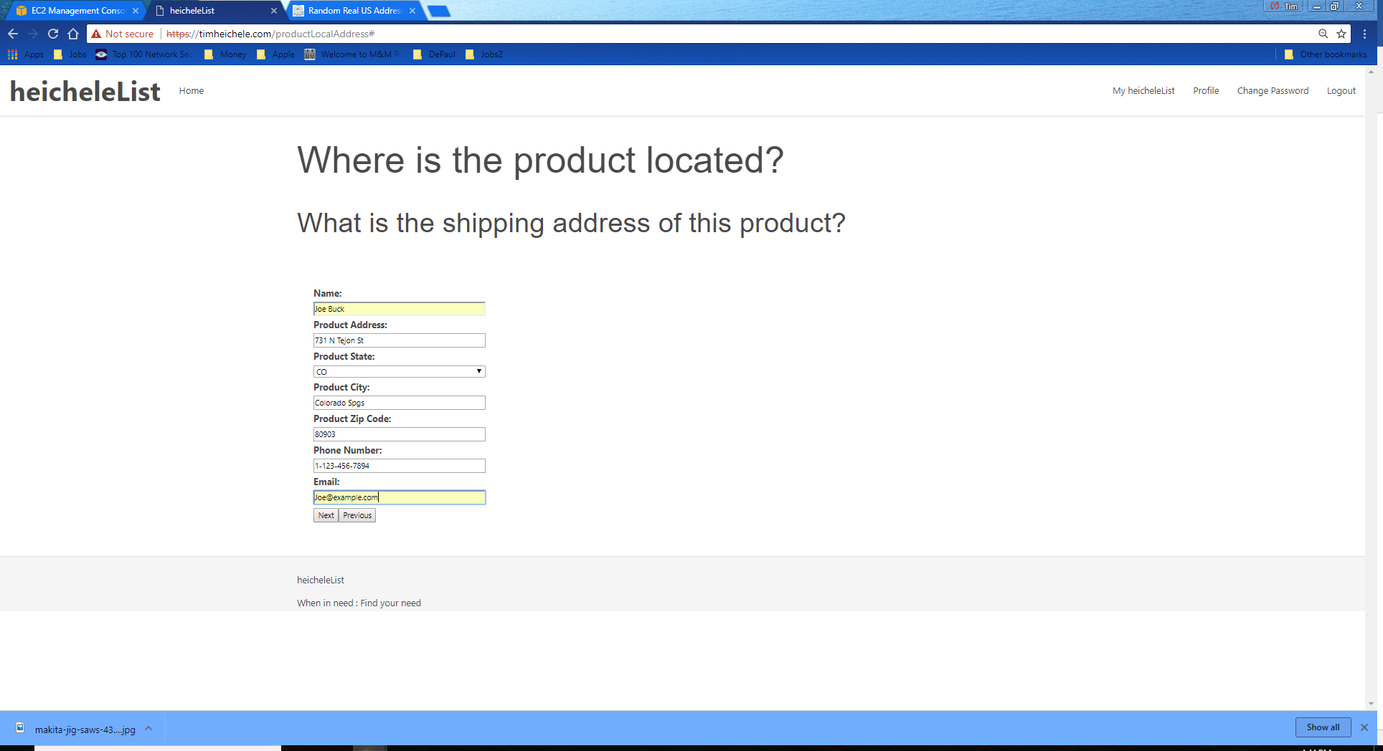

It is required for the product that is being donated to have a source address to be able estimate the shipping information and to actually ship the product.

**Product parcel information page**

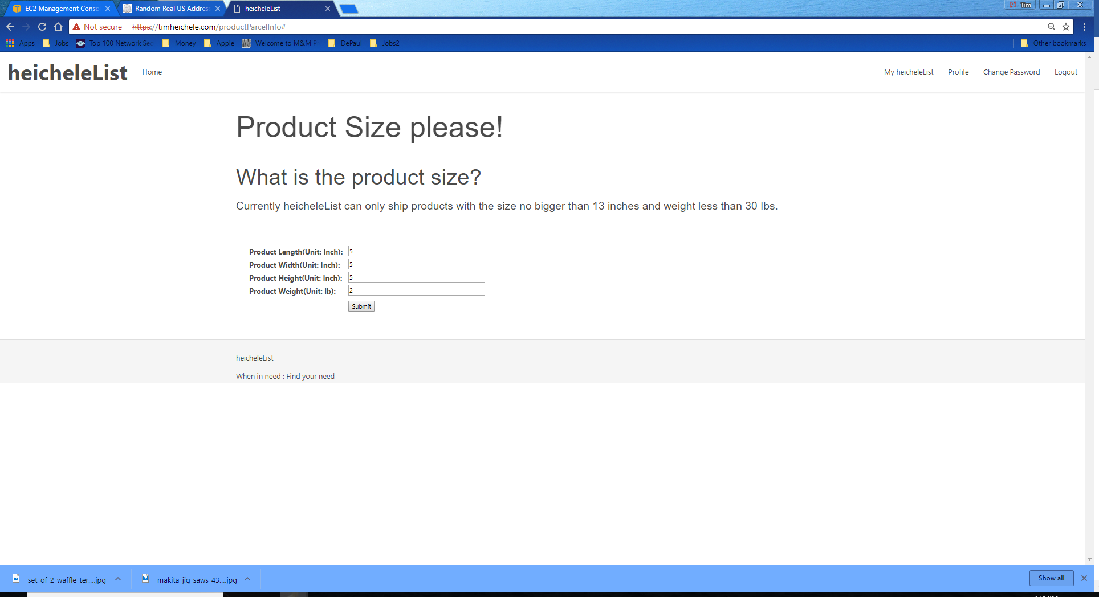

This is also required to be entered because we need the parcel size to be able to estimate the shipping information. Currently we are only using USPS

for shipping. Once all the information is entered for donation it will bring you back to the home navigation page.

**Purpose 2: Product Search**

Product Search page

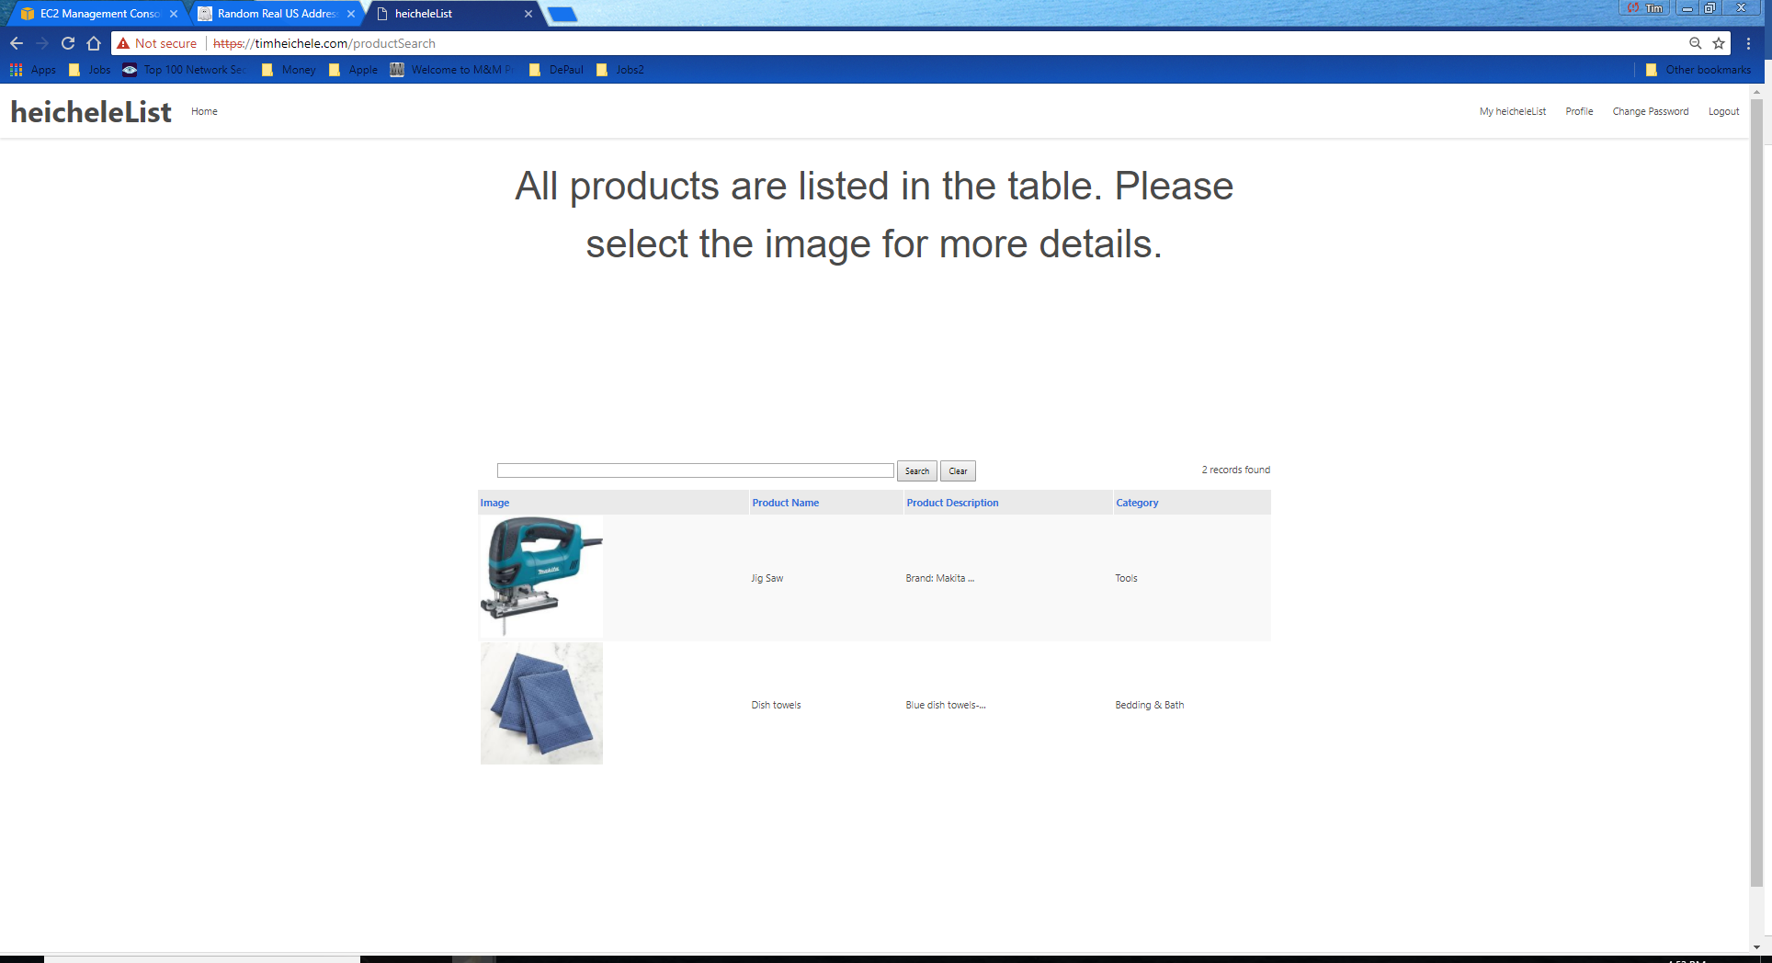

This page provides all the products that has been donated. User can click on the image to reveal more details about the product. And search for a product as well.

Product details page

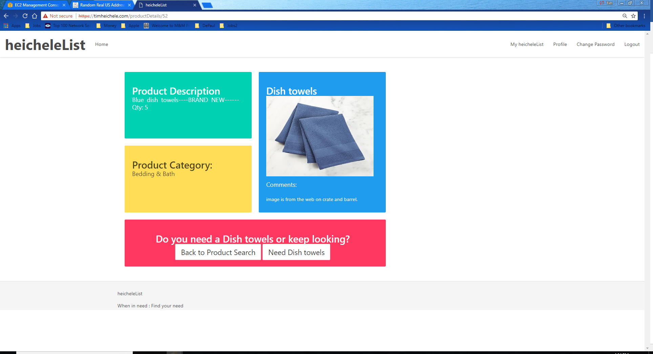

Allows user to see and read more about the details of the product. And if the user needs this product he can either go back to product search or request the product for shipment.

Detestation delivery information page

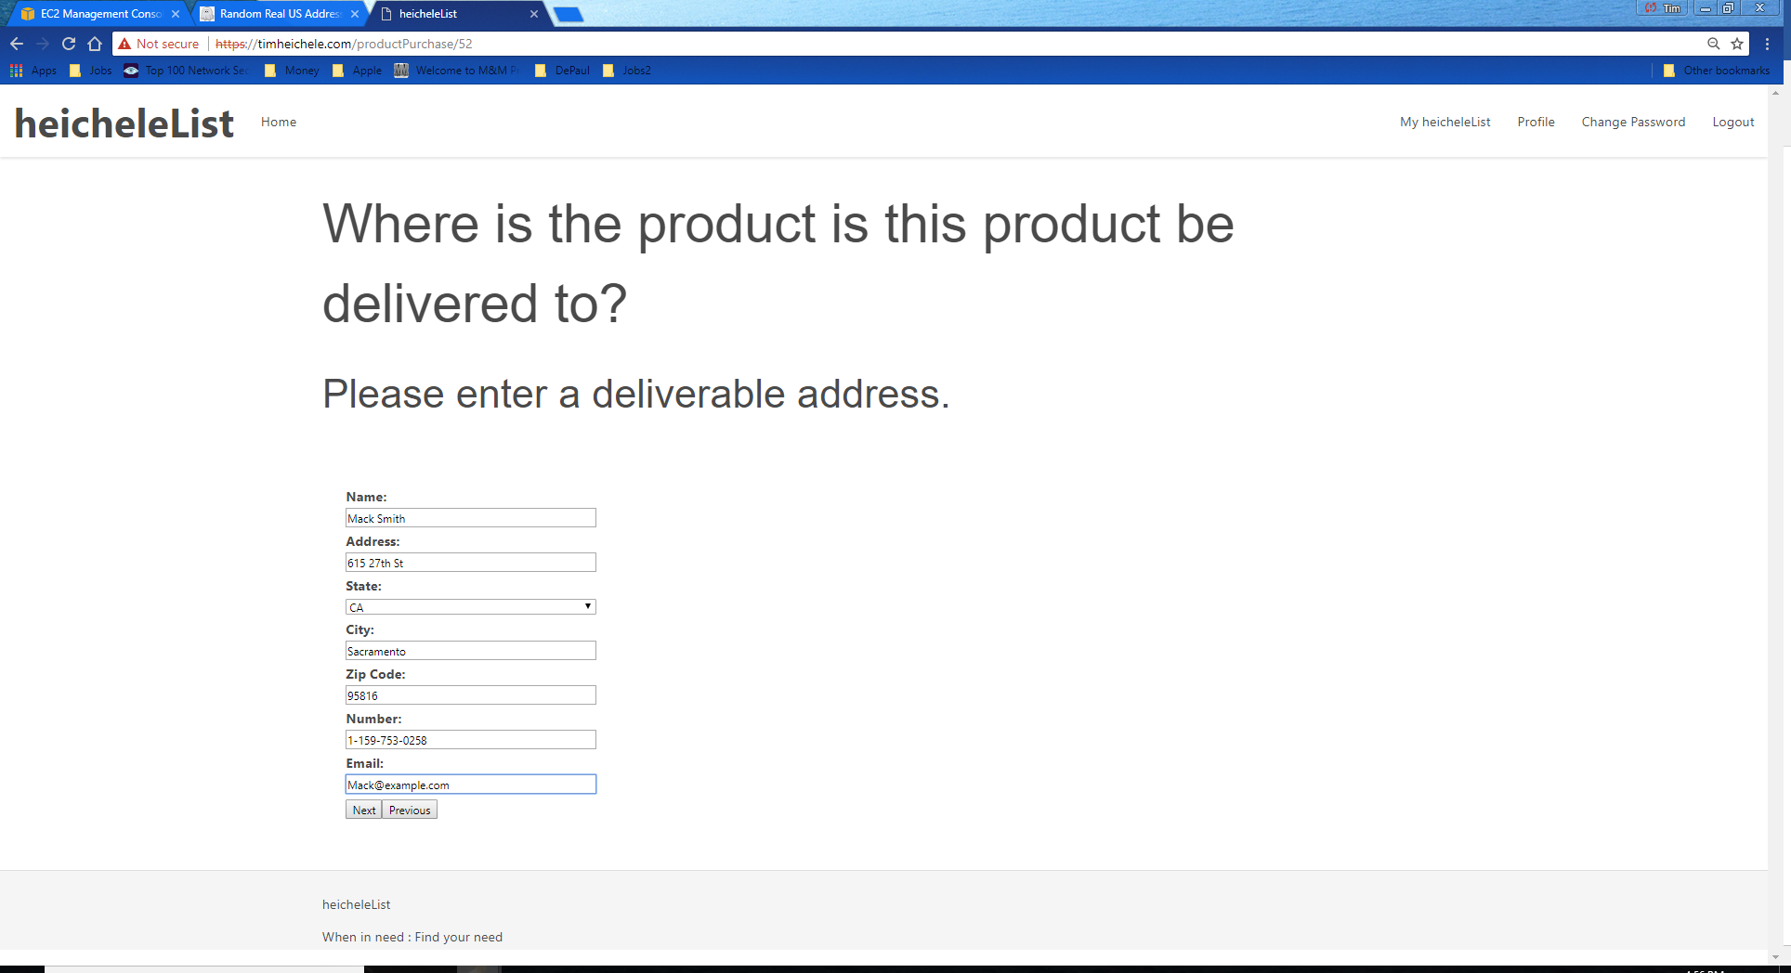

Allows the user to input where the product needs to be delivered has to be a valid US address.

Confirmation page

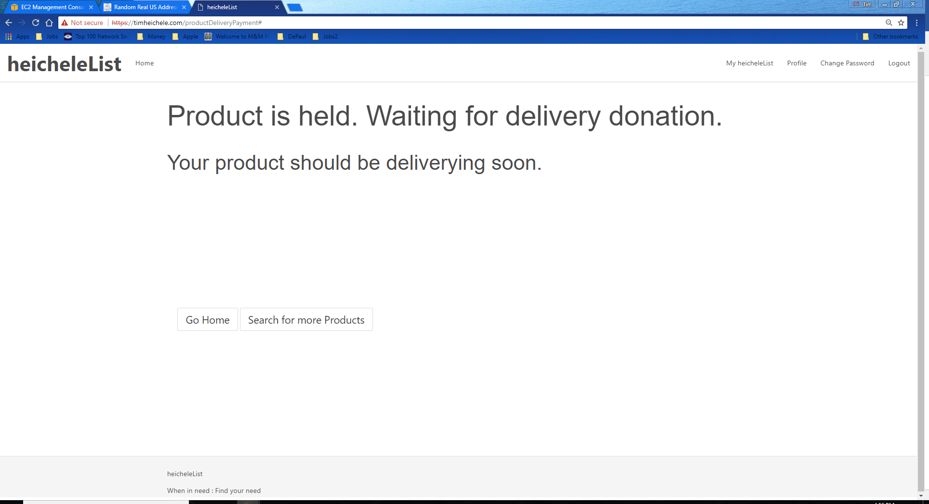

Notifies the user that the product is ready for a donor to pay for the delivery of the product. And at that point no one can also request delivery of that product.

**Purpose 3: Donate for Delivery**

Delivery donation search page

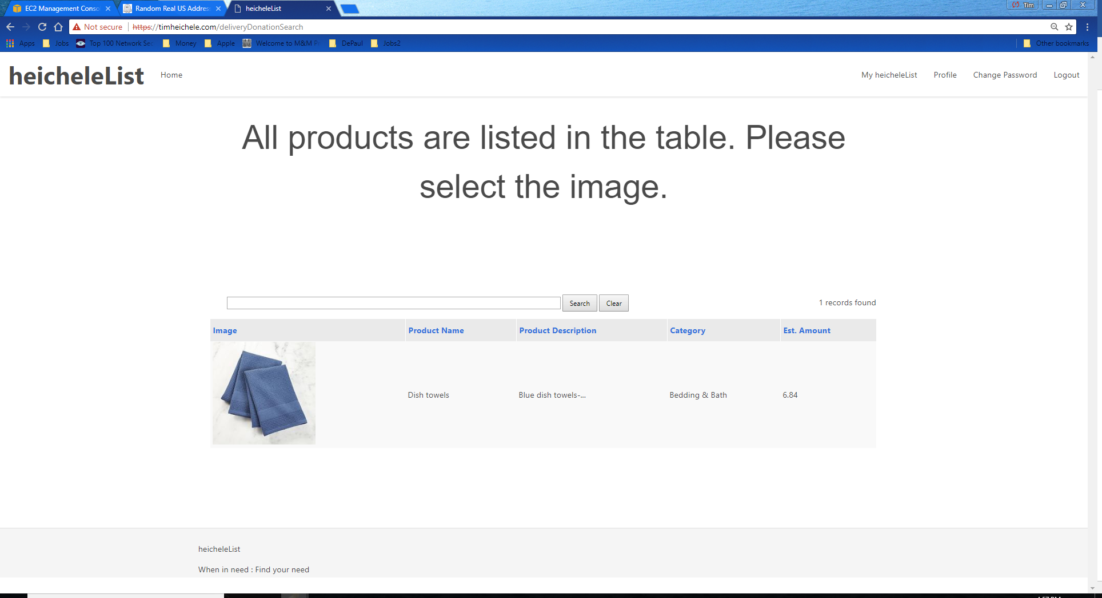

Allow the user to search for the donation estimated delivery cost that will fit his budge. Click on the image for the product for which the user would like to donate

the user money for delivery charges.

Delivery choice page

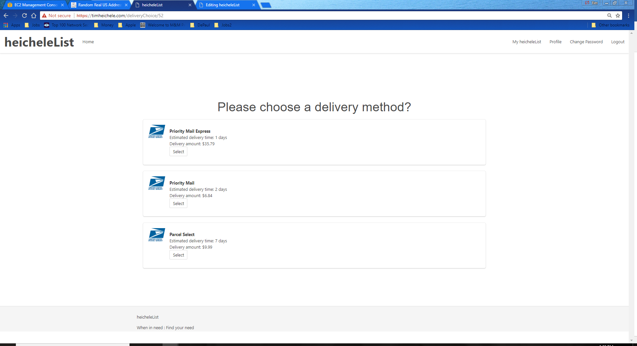

Allows the user to choose which shipping rate and estimated time of delivery he would like to donate.

Donation payment

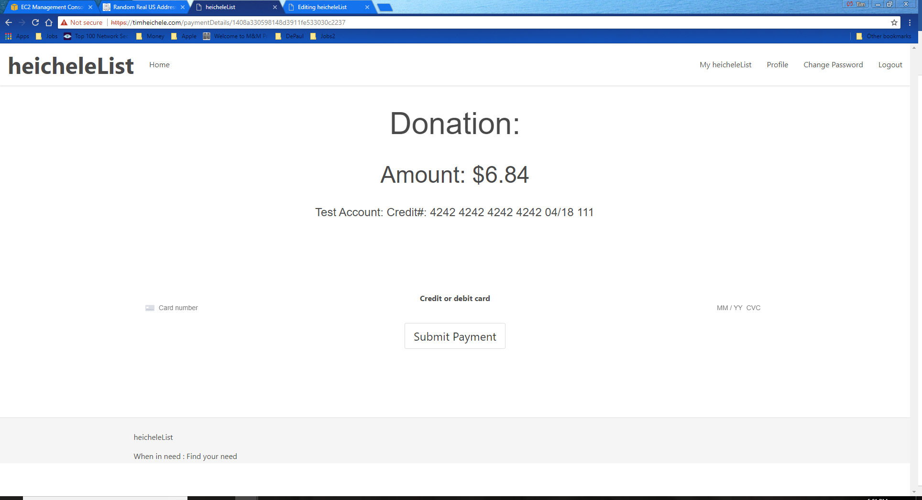

User can enter credit card information and submit payment.

Confirmation Page

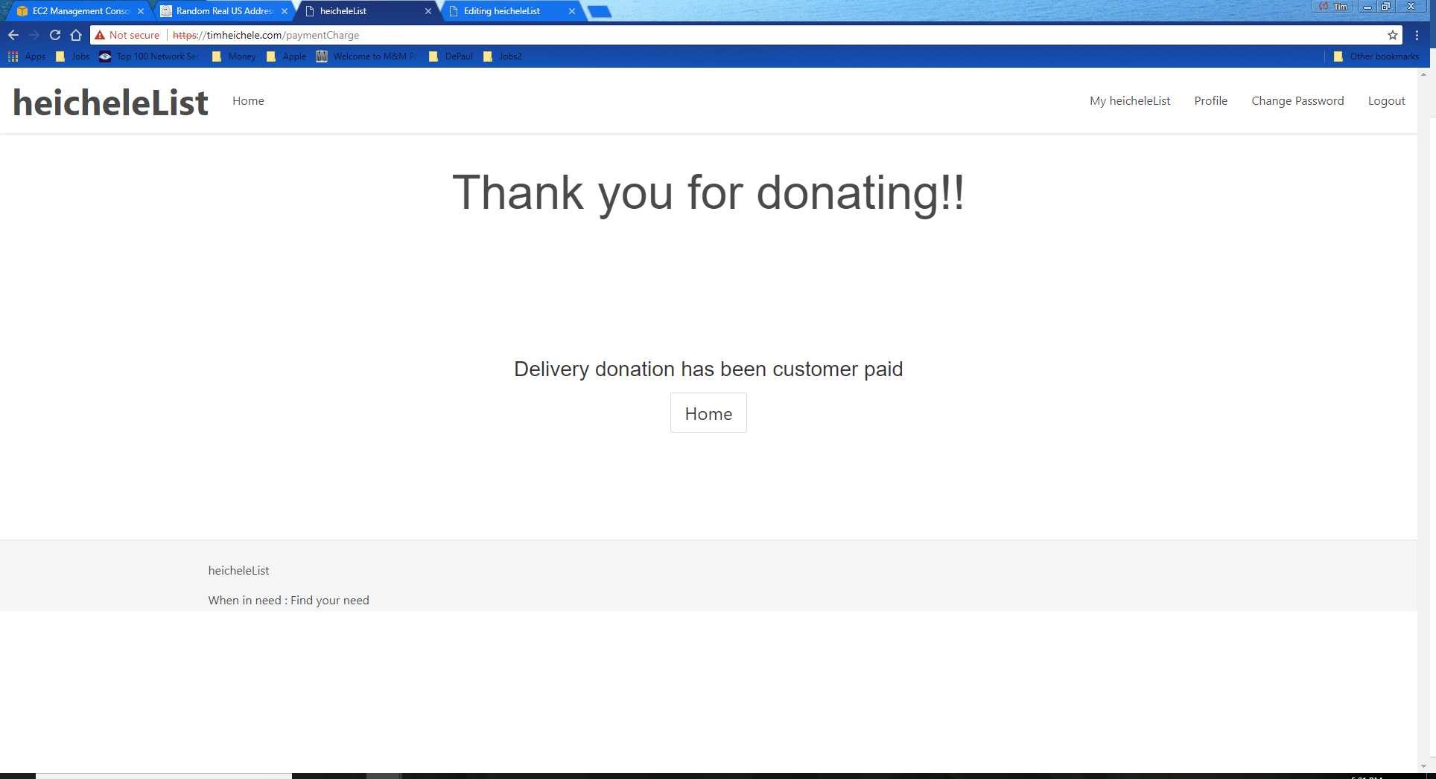

Notifies the user that the user donation has been charged and shipping of the product is in process.

**User history in myHeicheleList**

There are three section in user history and updates to a product in myHeicheleList

myHeicheleList Navigation Page

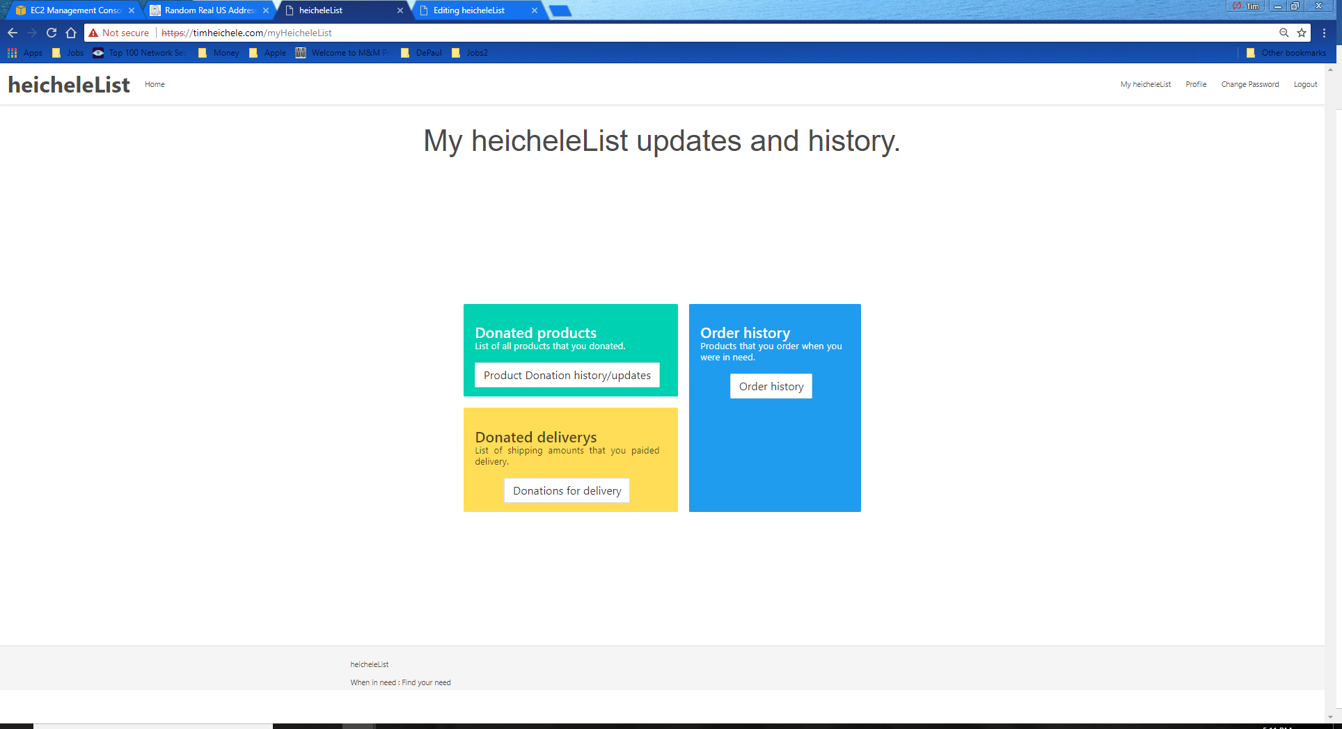

User can choose to go to any of the three section to review history of his use on heicheleList

**Section 1: Donated Products**

List of donated products

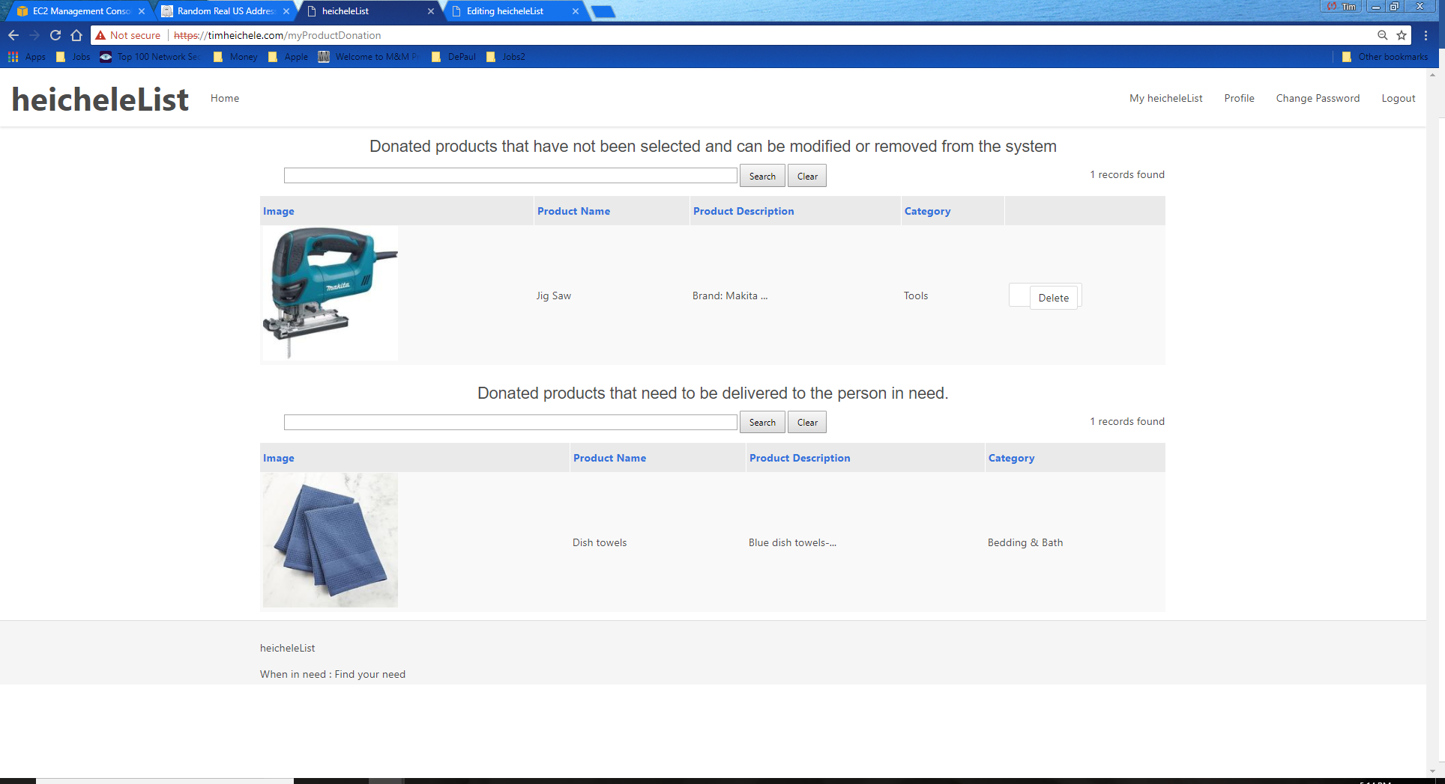

This page allows users to see currently listed products. Which allow the user to either perform edits to the product or they are allowed to delete the product. It also lists products that have been delieverd.

Product update page

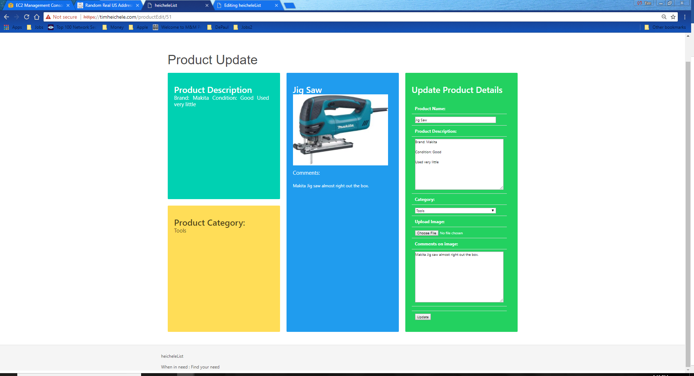

This page allows users to edit products thay have donated.

**Section 2: Order History**

Order history page

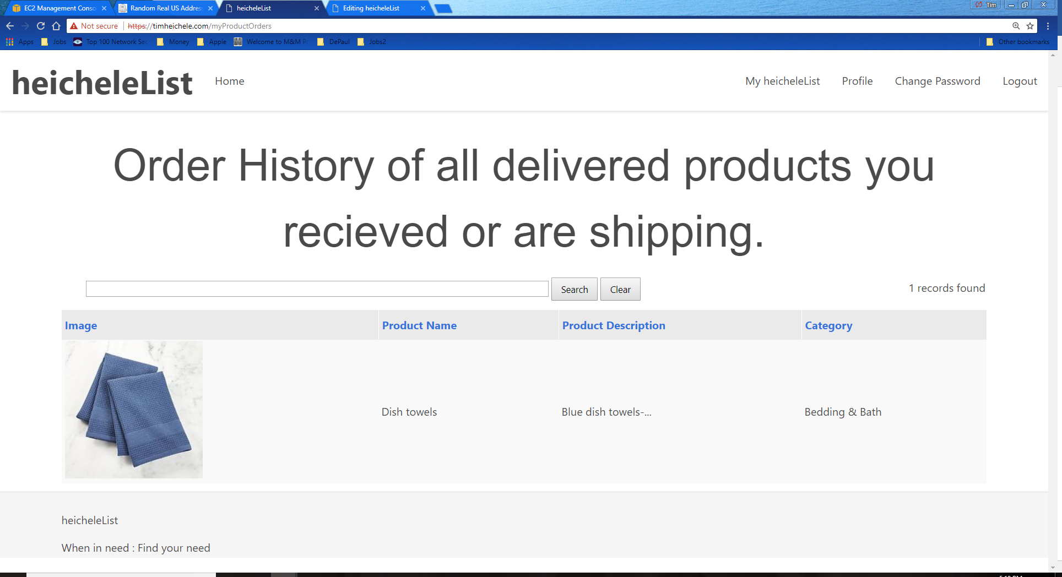

This allows user to see all the orders that they have requested.

**Section 3: Donated Delivery history**

Donated Delivery history page

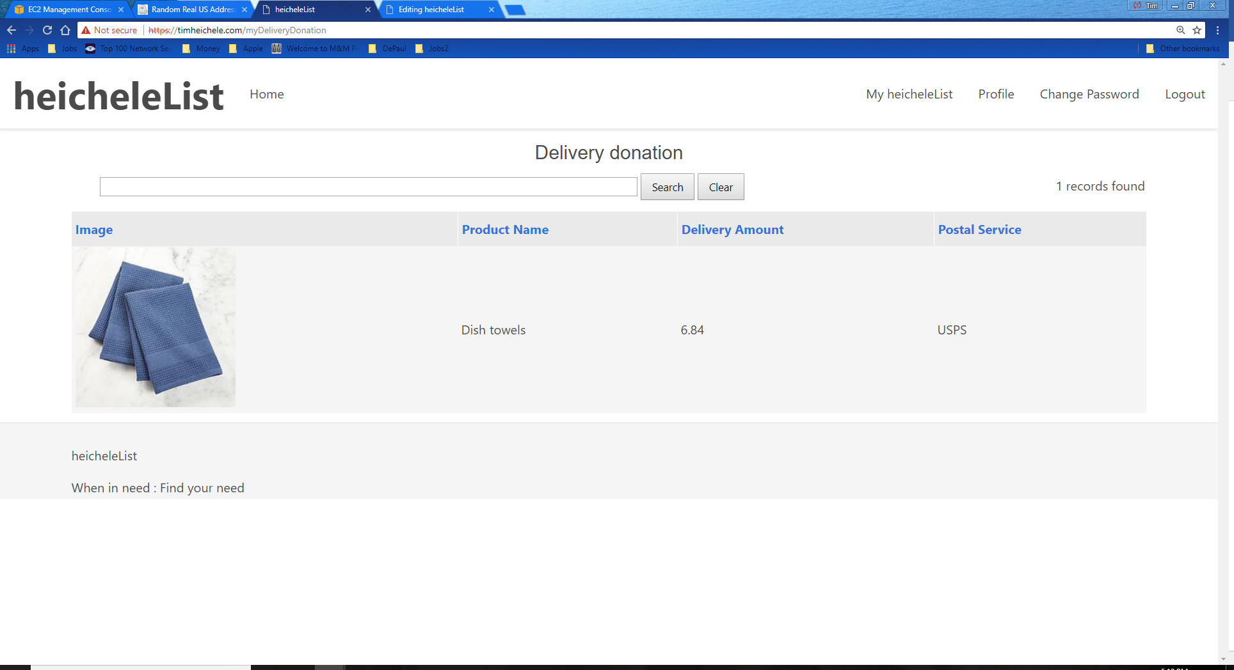

This allows user to see all the orders that they have requested.

**heicheleList pages that allow user profile and password updates.**

Profile page

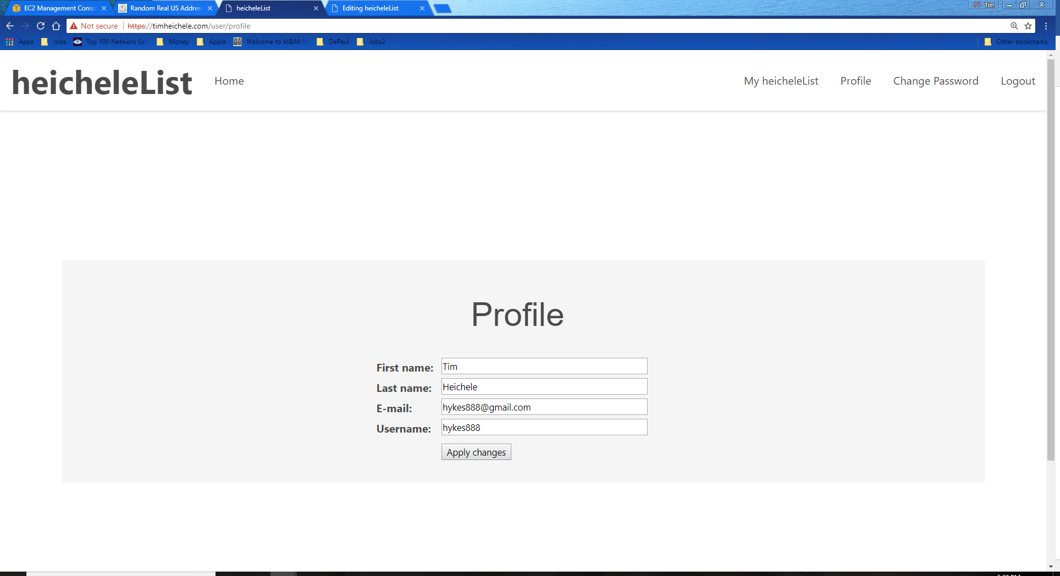

Allows updates to profiles in heicheleList

Change password page

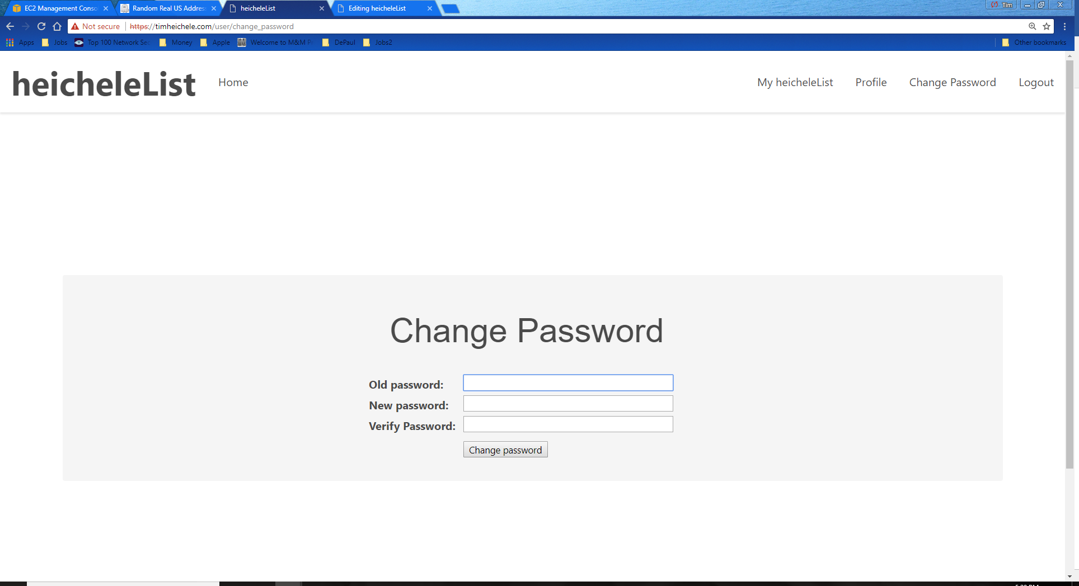

Allows the user to change passwords.